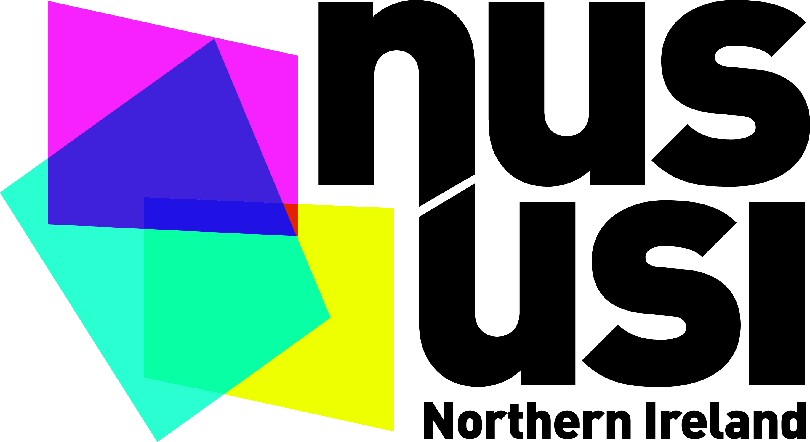

Registration Form

NUS-USI LGBT Conference 2014
Date: Wednesday 26 February
Time: 11:00 – 16:00
North West Regional College, Derry

Name:

University / College:

Contact number:

E-mail Address:

Special Requirements (Access / Dietary):

Please complete and return this form via e-mail to laura.stobo@nistudents.org by 2pm on Wednesday 19 February 2014

